Registering the Database in NetBeans IDE

Perform the following steps to register Java DB in the IDE.

1. In the Services window, click and expand the **Databases** folder, right-click the Java DB Database node and choose Properties to open the Java DB Settings dialog box.
2. For the Java DB Installation text field, enter the path to the Java DB root directory (javadb) that you specified in the previous step.
3. For Database Location, use the default location if a location is already provided. Click OK

Java DB Installation: **/usr/local/glassfish-4.1.1/javadb**

Database Location: **/root/database**

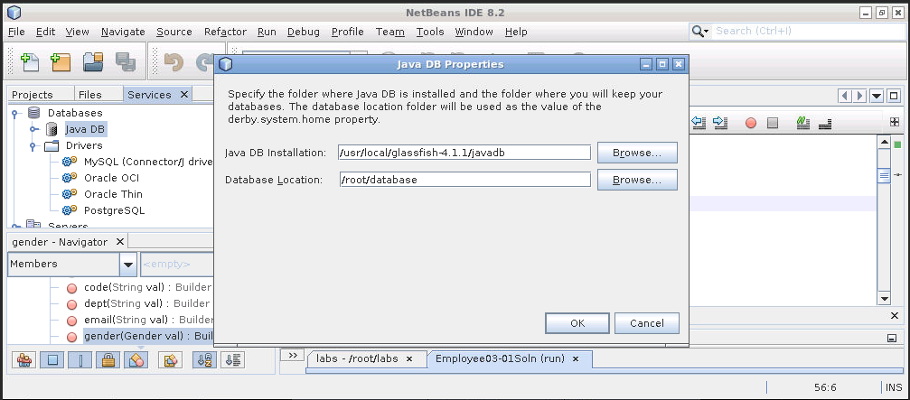

Enter master password “**fenago**”.

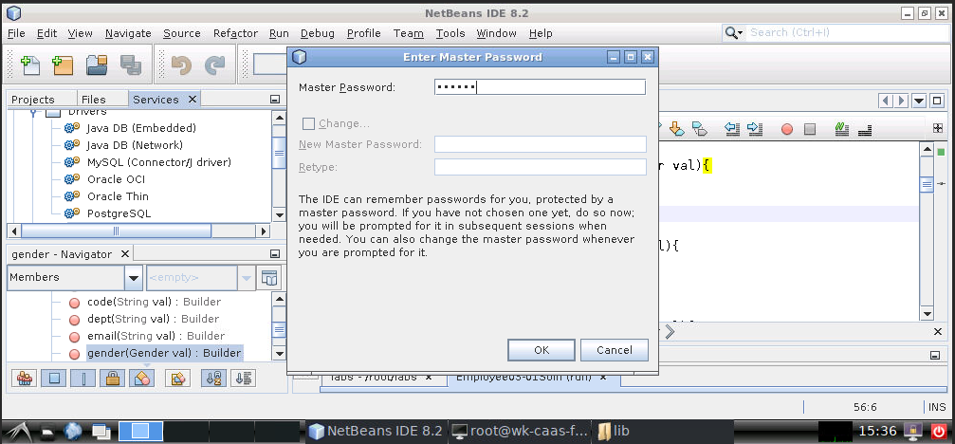

## Connecting to the Database

* Right-click JavaDB and select Start Server.
* Right-click JavaDB again and select Create Database. Enter the following information:

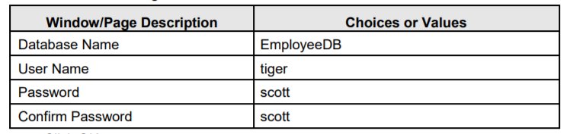

* Click “Execute Command” to open sql editor and write and execute sql statements.

